***AUTOMATIC VIDEO CALLING SECURITY SYSTEM***

* ***INTRODUCTION***

IT IS MADE FOR- Nowadays we are facing much robbery activities in our homes , shops etc .So I had developed a device that can solve this kind of problem in a very low cost. If we install cctv then it will cost 20,000 to 30,000 but my device will cost around Rs 3000 only.

* ***Components used***

|  |  |
| --- | --- |
| *Pir motion sensor* | *60* |
| *Servo motor* | *100* |
| *Arduino UNO board* | *450* |
| *Jumper wires X 3* | *05* |
| *Plastic case* | *20* |
| *Cell phone (for video calling)* | *1500* |
| *Sticks* | *05* |
| ***TOTAL*** | *RS 2,140* |

* ***PRINCIPLE***
* ***PIR SENSOR:-***

***When the sensor is inactive, then the two slots sense the same amount of IR.The ambient amount radiates from the outdoors, walls or room,etc. When a human body passes by, then it intercepts the first slot of the PIR sensor.***

***DIAGRAM***

***Pir sensor***

***–***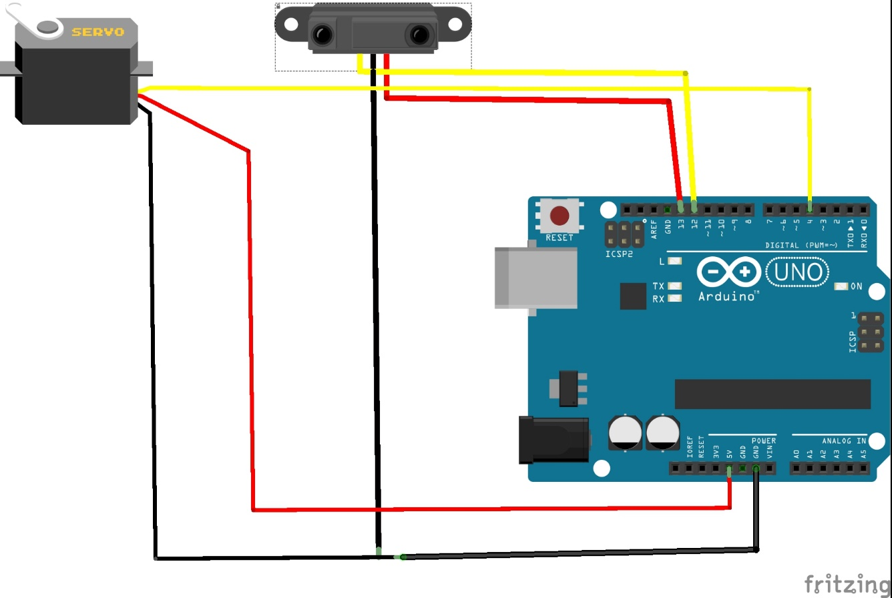

***CODE***

*#include <Servo.h>*

*Servo myservo;*

*int pos = 0;*

*int calibrationTime = 30;*

*long unsigned int lowIn;*

*long unsigned int pause = 5000;*

*boolean lockLow = true;*

*boolean takeLowTime;*

*int pirPin = 12;*

*int pirPos = 13;*

*void setup(){*

*myservo.attach(4);*

*Serial.begin(9600);*

*pinMode(pirPin, INPUT);*

*pinMode(pirPos, OUTPUT);*

*digitalWrite(pirPos, HIGH);*

*Serial.println("calibrating sensor ");*

*for(int i = 0; i < calibrationTime; i++){ Serial.print(calibrationTime - i);*

*Serial.print("-");*

*delay(1000);*

*}*

*Serial.println();*

*Serial.println("done");*

*while (digitalRead(pirPin) == HIGH) {*

*delay(500);*

*Serial.print(".");*

*}*

*Serial.print("SENSOR ACTIVE");*

*}*

*void loop(){*

*if(digitalRead(pirPin) == HIGH){*

*for(pos = 0; pos < 180; pos += 1) {*

*myservo.write(pos);*

*delay(5);*

*}*

*for(pos = 180; pos<=1; pos-=1) {*

*myservo.write(pos);*

*delay(5);*

*}*

*if(lockLow){*

*lockLow = false;*

*Serial.println("---");*

*Serial.print("motion detected at ");*

*Serial.print(millis()/1000);*

*Serial.println(" sec");*

*delay(50);*

*}*

*takeLowTime = true;*

*}*

*if(digitalRead(pirPin) == LOW){*

*if(takeLowTime){*

*lowIn = millis();*

*takeLowTime = false;*

*}*

*if(!lockLow && millis() - lowIn > pause){*

*lockLow = true;*

*Serial.print("motion ended at ");*

*Serial.print((millis() - pause)/1000);*

*Serial.println(" sec");*

*delay(50);*

*}*

*}*

*}*